**Data structures ( C ) Lab Exercise**

***At the end of the course, it is mandatory to submit the Lab Record with solutions to all these problems. The behaviour of the programs has to be studied with different sets of inputs and observe the actual running patterns. The format of the record for each problem is as follows:***

**(1) Statement of the problem**

**(2) Explanation of the problem**

**(3) Steps/ Algorithm to solve the problem**

**(4) Program code in C**

**(5) Output of the program with different input data sets**

**(6) Explanation of the output**

**Programs on Array:**

1. Write a C Program to calculate Sum & Average of an Array of integers.
2. Write a C Program to Find the Largest number in a given Array and its index.
3. Write a C program to print an array of numbers along with their addresses.
4. [Write a C Program to](http://www.sanfoundry.com/c-program-compute-sum-two-one-dimensional-arrays-using-malloc/)input two matrices of 5×5 add them and output the resultant matrix.
5. [Write a C Program to](http://www.sanfoundry.com/c-program-compute-sum-two-one-dimensional-arrays-using-malloc/)input two matrices of 5×5 multiply them and output the resultant matrix.

**Programs on linear data structure-**

1. Write a C program to implement Stack with array as a data structure.
2. Write a C program to implement queue with array as a data structure.
3. Create a singly linked circular list with 10 nodes with given 10 integer numbers storing one number in one node.
4. Create a doubly linked list with 10 nodes with given 10 integer numbers storing one number in one node.
5. Create a circular linked list with 10 nodes with given 10 integer numbers storing one number in one node.

**Trees and Graphs**

1. Create a binary tree with a given set of keys and output the data with 3 tree traversals (Pre-order, In-order and post-order traversal).

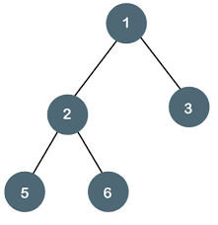

1. Create a Binary Search Tree(BST) for below figure write a C module to search for a given value in BST.

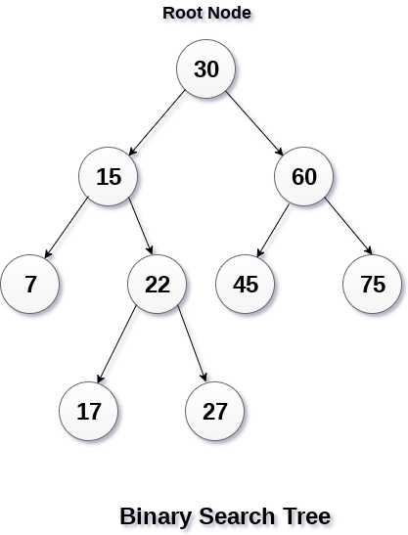

1. Write a C program to implement Breadth First Search Traversal for below graph.

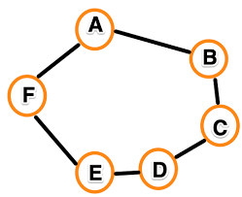

1. Write a C program to implement Depth First Search Traversal for below graph.



1. Write a C Program to search for a number in the one dimensional array using linear search algorithm.
2. Write a C Program to Sort the Array in an Ascending Order using Bubble sort.
3. [Write a C Program to](http://www.sanfoundry.com/c-program-compute-sum-two-one-dimensional-arrays-using-malloc/)sort an array in descending order using Selection sort.
4. [Write a C Program to](http://www.sanfoundry.com/c-program-compute-sum-two-one-dimensional-arrays-using-malloc/)sort an array in ascending order using Insertion sort.
5. [Write a C Program to](http://www.sanfoundry.com/c-program-compute-sum-two-one-dimensional-arrays-using-malloc/)sort an array in descending order using Heapsort.
6. Write a C Program for [Binary search](http://www.programmingsimplified.com/executable/c/binary-search.exe) .